Stand in Love
Kick Off
Saturday, April 2, 2016
11AM-1PM
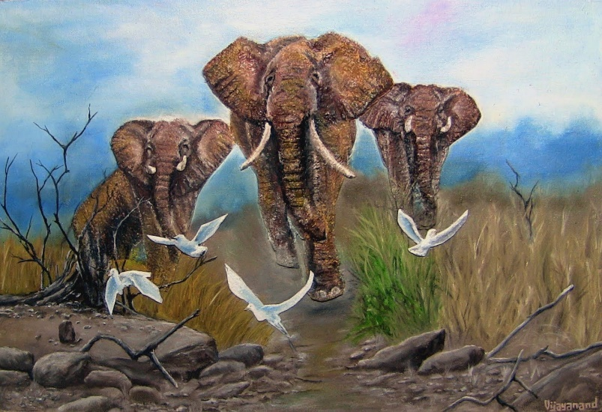

The members of an African elephant family group take good care of one another. If one of them is sick or injured others will stay with it to defend it. If an elephant is wounded and cannot stand, two elephants will stand on each side of the injured elephant and hold it up until it is healed. How can we at UBTS stand in Love with each other?
Purpose of Stand in Love Triads
In-reach within UBTS designed to foster fellowship, create connection and support, and model Love in action.
Formation of Triads
- Angela will pray over all names who signed up to participate and randomly pull names to form groups; Triads will be announced at the kick off.
Activity of Triads
- Weekly Stand in Love Prayer Call. Prayer format and call in #’s will be distributed.
- Weekly spotlight on one individual to stand in the middle and receive messages of loving support from the other individuals in the triad.
- Monthly get together. Each member gets a turn in selecting their social (3 socials total).
If you have not signed up to participate and are interested, please email Angela Denton unitybytheshore@aol.com or sign up in person at Unity by the Shore.

