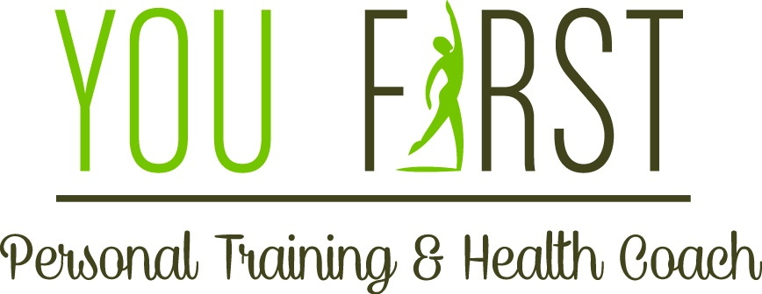Group Exercise Class

Class Dates 11/6, 11/19, 11/23
60 minute sessions – 11/6 class-5:30 pm, 11/19 class-5:00 pm & 11/23 class-5:30 pm
Location: Unity by the Shore
Love offering $10.00 per week

This program is designed specifically to meet anyone at any level of
fitness. Our objective is to offer you the opportunity to create a
healthy lifestyle. This class encompasses mind, body, and
spirit in every 1 hour session.

Program includes:
- Bodyweight strength building
- Speed and agility
- Stretch and meditation

Please bring any weights or fitness bands you may already own to class to ensure we have enough to share.

You First Personal Training Owner ~ Vicky Farrell
Certified NASM Personal Trainer, Certified NASM Fitness Nutrition Specialist, TRX Certified
Always interested in physical activity, Vicky grew up dancing ballet, tap, jazz and hip hop and as an adult competes in ballroom dancing. Her passion for health and fitness inspired her to run a half marathon and participate fitness competitions. She placed 2nd, 3rd, and 4th in regional fitness shows and placed in the Top 10 at a national show. She became a personal trainer in 2010 and has helped her clients regain balance, become better athletes, regain their health, and drop over 100lbs. She currently trains clients from ages 18 to 87. Her passion lies in getting to know her clients on a personal level to help inspire and motive while helping to set and maintain their fitness goals and change their lives.
Call 732.610.6486 for more information Find us on Facebook - Vicky Farrell - Personal Trainer

