The Fifth Agreement: A Practical Guide to Self-Mastery

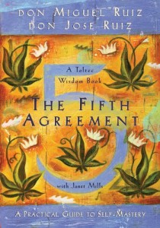

A New York Times bestseller for over seven years, The Four Agreements transformed the lives of millions of people around the world with a simple yet profound message. Now author and renowned spiritual teacher Don Miguel Ruiz has collaborated with his son, Don Jose Ruiz, on its long-awaited sequel The Fifth Agreement: A Practical Guide to Self Mastery. This captivating book expands upon The Four Agreements with fresh insights and empowers us to recover faith and authenticity with a powerful new agreement: Be skeptical, but learn to listen.
The Fifth Agreement uses doubt as a tool to discern the truth. Doubt takes us behind the words we hear to the intent behind them. By being skeptical, we don’t believe every message we hear; we don’t put our faith in lies, and when our faith is not in lies, we quickly move beyond emotional drama, victimization, and the limiting belief systems our “domestication” has programmed us with.
According to the Don Miguel and his son, The Fifth Agreement prepares us to return to our innate wisdom, and live our lives based on truth.. The truth leads to self-mastery, to a life that’s very easy; believing in lies leads to needless conflict and human suffering. As messengers of truth we are free to express ourselves and can live a life without fear, regret, or shame.~ Ruiz

6 Week Book Study held at 2 different times for your convenience !

Thursdays 1:00-3:00 PM September 10th- October 15st
Tuesdays 6:30-8:30 PM September 15th- October 27th (no class on Oct 6th)
Facilitated by Angela Denton MA; P.D. MFT; LUT
Cost: Love Offering

