AGELESS VITALITY

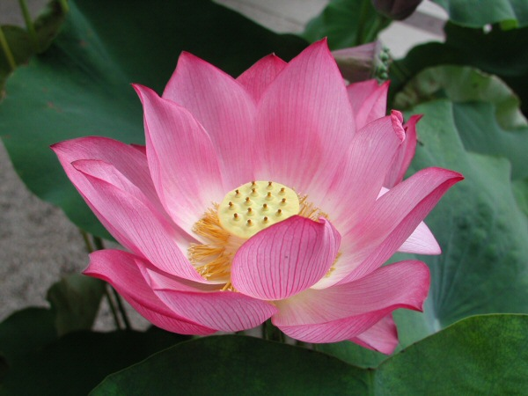

Simple movements for body, mind, and spirit
Increase Balance, Range of Motion, Peace of Mind
No experience or equipment necessary
Taught by Kat Grausso
When: September 17th
Thursdays 3:15-4:15
Cost: $10

