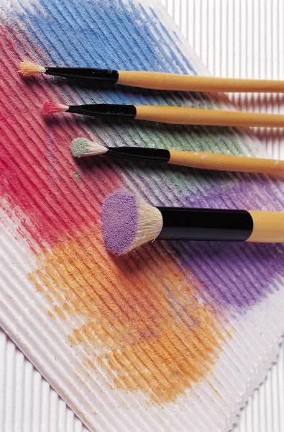

Unity by the Shore
Presents:

“Art from the Heart”
Workshop

Taught By Mary Phillips

Saturday, May 31, 2014
10:00 am-1:00 pm

Recommended Materials to Bring to Class:
Pictures, Pastels, Pastel Paper Pad (18x24), An Old Bath Or Hand Towel, Vine Charcoal, Kneaded Eraser, Firm Backing (Foam Core), Masking Tape, etc.

Suggested Donation: $25

